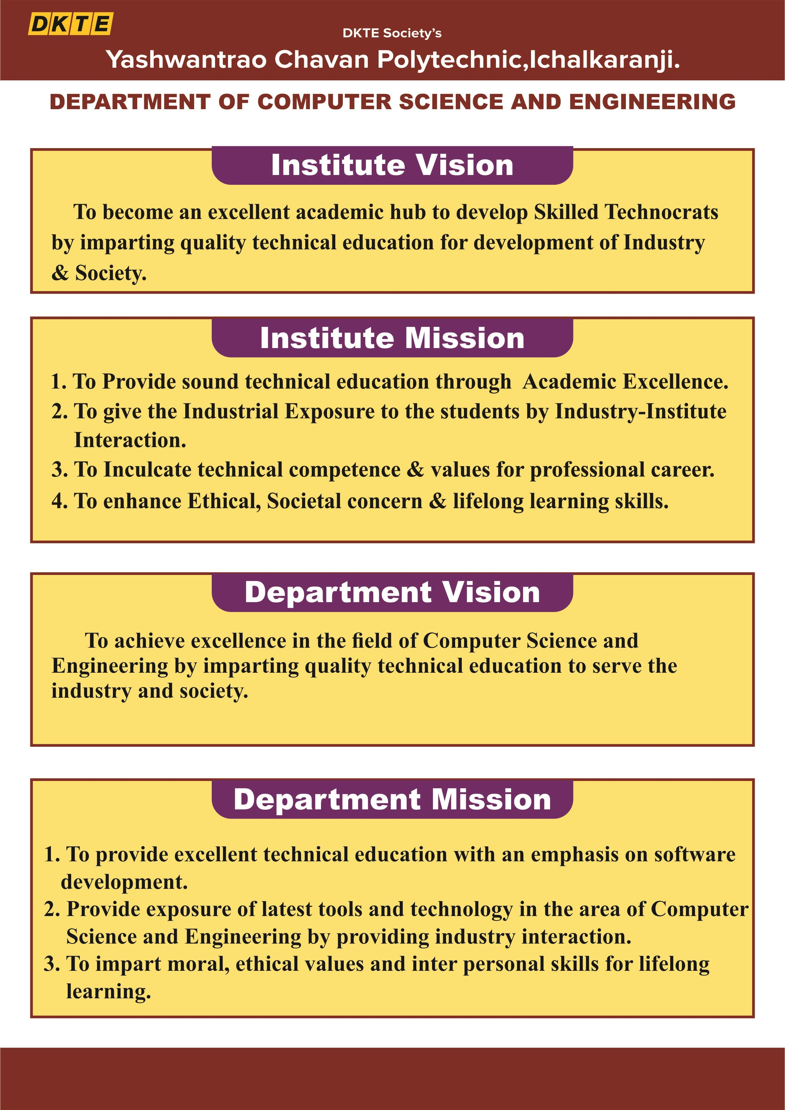

D.K.T.E. Society’s

Yashawantrao Chavan Polytechnic, Ichalkaranji.
Department of
Computer Science and Engineering A
REPORT ON,

“INTERNSHIP”
SUBMITTED BY,

Roll No | Enrolment No. | Exam Seat No. | Student Name
48 | 24213200231 |  | Atharv Milind Suryavanshi

Under the Guidance of
Mrs. S. M. Mali
Academic Year: 2026-27


D.K.T.E. SOCIETY’S

YASHAWANTRAO CHAVAN POLYTECHNIC, ICHALKARANJI.
DEPARTMENT OF

COMPUTER SCIENCE AND ENGINEERING
CERTIFICATE

THIS IS TO CERTIFY,

Roll No | Enrolment No. | Exam Seat No. | Student Name | Sign
48 | 24213200231 |  | Atharv Milind Suryavanshi

HAVE SUCCESSFULLY COMPLETED THE PROJECT DESIGN WORK ENTITLED,

“INTERNSHIP”
In partial fulfilment of Diploma in Computer Science and Engineering at MSBTE, Mumbai.
DATE:
PLACE: ICHALKARANJI

Mrs. S. M. Mali Mr. R. A. Hatgine Mr. A. P. Kothali

(MENTOR) (HOD) (PRINCIPAL)

(EXTERNAL Examiner)

ACKNOWLEDGEMENT
An endeavor over long period can be successful only with advice and guidance of many well-wishers. We thanks to HOD Mr. R. A. Hatgine, of Computer Science and Engineering for this opportunity. We would like to thank the Computer Science and Engineering department for assistance and constant source of encouragement.
We wish to express our profound and deep sense of gratitude to Mrs. S. M. Mali for sparing their valuable time to extend help in every step of our project.

Name of Student:
1. Atharv Milind Suryavanshi

ABSTRACT

This report encapsulates the industrial training experience undertaken at Edunet Foundation in collaboration with IBM under the IBM SkillsBuild initiative. The training focused on enhancing digital competencies in cybersecurity and data science through a structured hybrid learning model. It outlines the organizational framework of Edunet Foundation, its mission to bridge academic and industry gaps, and its strategic partnerships with global tech leaders.
The document details the software tools and platforms used during the program, including Python, IBM Watson Studio, Kali Linux, and Wireshark, along with their specifications, usage, and maintenance protocols. It further explores the methodologies adopted—ranging from online modules and mentor-led sessions to hands-on labs and mini projects.
Testing procedures involved unit testing, performance analysis, and ethical cybersecurity simulations. Safety protocols emphasized data protection, cyber hygiene, and secure coding practices. The report also highlights practical experiences such as machine learning implementation and network threat detection, culminating in a final project on anomaly detection.
Challenges faced during the training, including debugging and network configuration, are discussed alongside personal reflections. The report concludes by affirming the program’s role in preparing students for real-world IT careers through experiential learning and industry-aligned skill development.

INDEX

CHAPTER NO. | TITLE | PAGE NO.
1. | Organization structure of Industry and general layout. | 1 - 3
2. | Introduction to Industry / Organization (history, type of products and services, turn over and number of employees etc.) | 4 - 6
3. | Types of Major Equipments/raw materials/ instruments/machines/ hardware/software used in industry with their specifications, approximate cost, specific use and routine maintenance done | 7 - 7
4. | Processes/ Manufacturing Manufacturing techniques and methodologies and material handling procedures | 8 - 8
5. | Testing of Hardware/Software/ Raw materials/ Major material handling product (lifts, cranes, slings,pulleys, jacks, conveyor belts etc.) and material handling procedures | 9 - 9
6. | Safety procedures followed and safety gears used by industry. | 10- 10
7 | Particulars of Practical Experiences in Industry/Organization if any inProduction/Assembly/Testing/Maintenance | 11 – 11
8. | Detailed report of the tasks undertaken (during the training). | 12 - 12
9. | Special/challenging experiences encountered during training if any (may include students liking &disliking of workplaces). | 13 - 13
10. | Conclusion | 14 – 14
11. | References / sources of information | 15 – 15

